Practical Project Part 1 Report

CST 8002 Programming Language Research Project

Student Name : Dhruv Sharma

Professor Name: Stanley Pieda

Due Date : 1st Feb 2026

Evidence of Learning
Variables:
Variavbles are used to store information that the program can use and change. In this project, Variable keep data from dataset like the Site identification, Area, Visit date, Start time, Species code, Count. [1] [2]
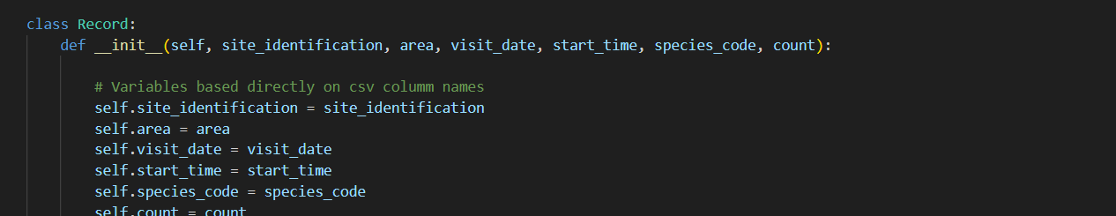
Figure 1: In this figure class Record using variables (Site identification, Area, Visit date, Start time, Species code, Count.

Methods:
Method is a block of code that runs only when called it. It helps make the program organized and reuseable. In this project methods are used to read data of student name [3]
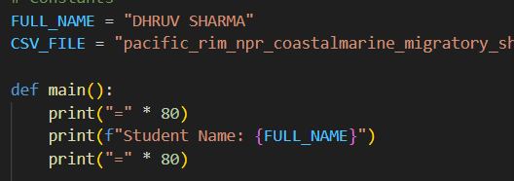
Figure2: In this figure as you can see I used main method to print student name .

Loop Structure:
Loops let you run same code multiple time. In this project a FOR loop goes through the dataset and shows all the records. [4]
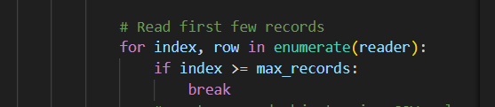
Figure3: In this figure I used FOR loop with index > = max_records

File Input Output Reading from Dataset.py
File IO is used to open and read files from outside the program. In this code it reads the CSV dataset from get pacific_rim_npr_coastalmarine_migratory_shorebird_habitat_use_2011-2017_data.csv file. [5]
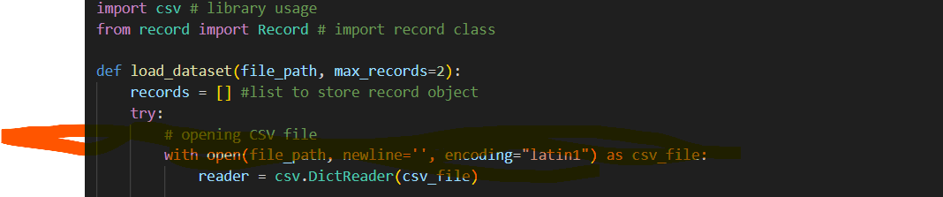
Figure 4: In this figure used with open to open csv file and encode it in latin1.
Exception Handling :
Exception Handling helps the program deal with errors without crashing. In this project, it manages missing or damaged dataset files. [6]
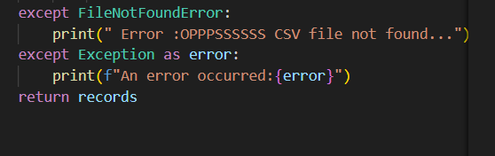
Figure5: In this figure I used 2 error handing to avoid program crashing.

Use of Library :
Libraries give pre-made code to make programming easy. This program uses python in build library to read csv files. [7]
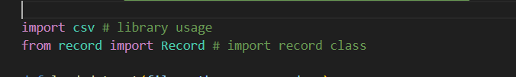
Figure6 : I used import csv inbuilt library of python.
List data structures:
List store many items in order. This project uses a list to store all the record object. [8]
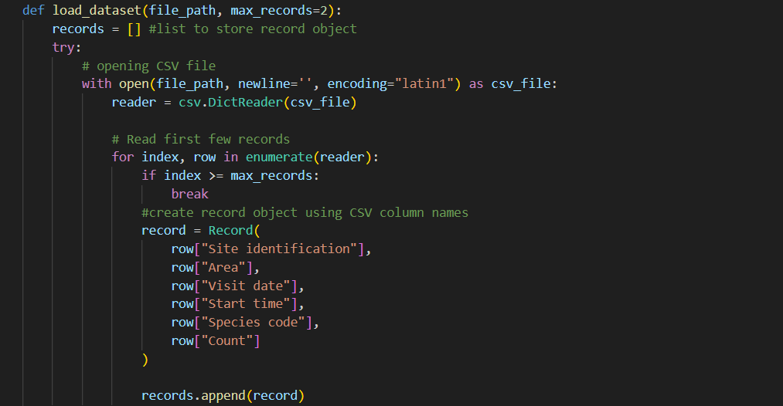
Figure7 In this figure I used list of data structures read row from file and add in same line each row and data separated by comma (,).

Program Execution:
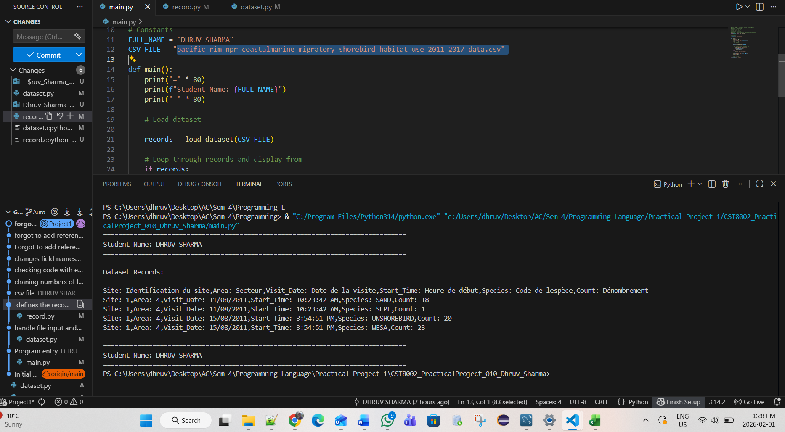
Figure8 In this figure shows number of first 5 record from CSV file. First line is in French rest 4 are actual records with student name before and after print the records.

Error Handing Screenshot

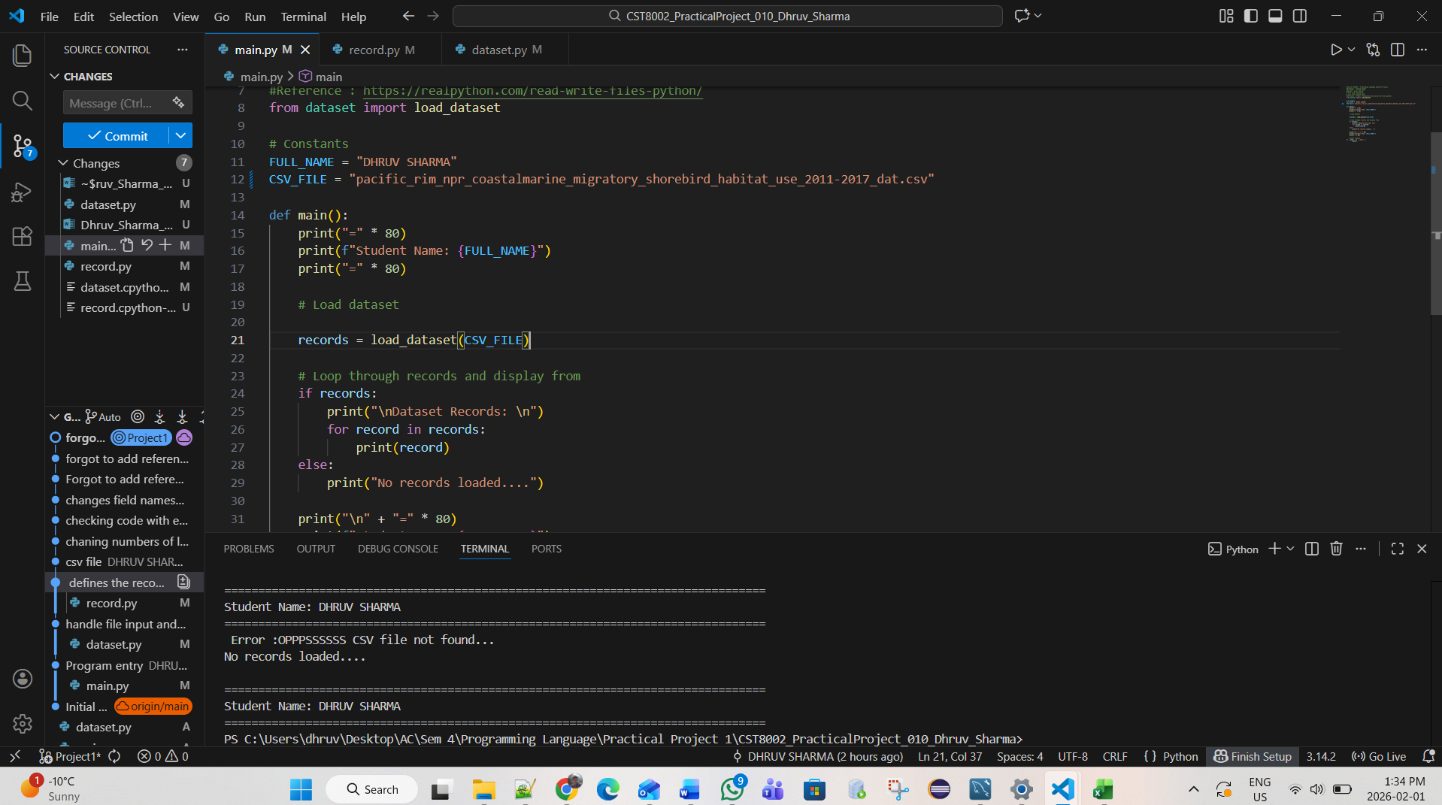
Figure9: In this figure I changes the file in and run the program as result it showing error like CSV file not found.

References

[1] | w3schools.com, "Python Variables," N.D.. [Online]. Available: https://www.w3schools.com/python/python_variables.asp. [Accessed 01 Feb 2026].
[2] | w3schools.com, "Python __init__() Method," N.D.. [Online]. Available: https://www.w3schools.com/python/python_class_init.asp. [Accessed 01 Feb 2026].
[3] | L. P. Ramos, "method," 19 Sep 2025. [Online]. Available: https://realpython.com/ref/glossary/method/. [Accessed 01 Feb 2026].
[4] | learnpython.org, "Loops," N.d. [Online]. Available: https://www.learnpython.org/en/Loops. [Accessed 01 Feb 2026].
[5] | W3school.com, "Python File Open," N.D.. [Online]. Available: https://www.w3schools.com/python/python_file_open.asp. [Accessed 01 Feb 2026].
[6] | www.geeksforgeeks.org, "Python Exception Handling," N.D. [Online]. Available: https://www.geeksforgeeks.org/python/python-exception-handling/. [Accessed 01 Feb 2026].
[7] | python.org, "csv — CSV File Reading and Writing," N.D. [Online]. Available: https://docs.python.org/3/library/csv.html. [Accessed 01 Feb 2026].
[8] | J. Mertz, "Reading and Writing Files in Python (Guide)," N.d. [Online]. Available: https://realpython.com/read-write-files-python/. [Accessed 01 Feb 2026].

